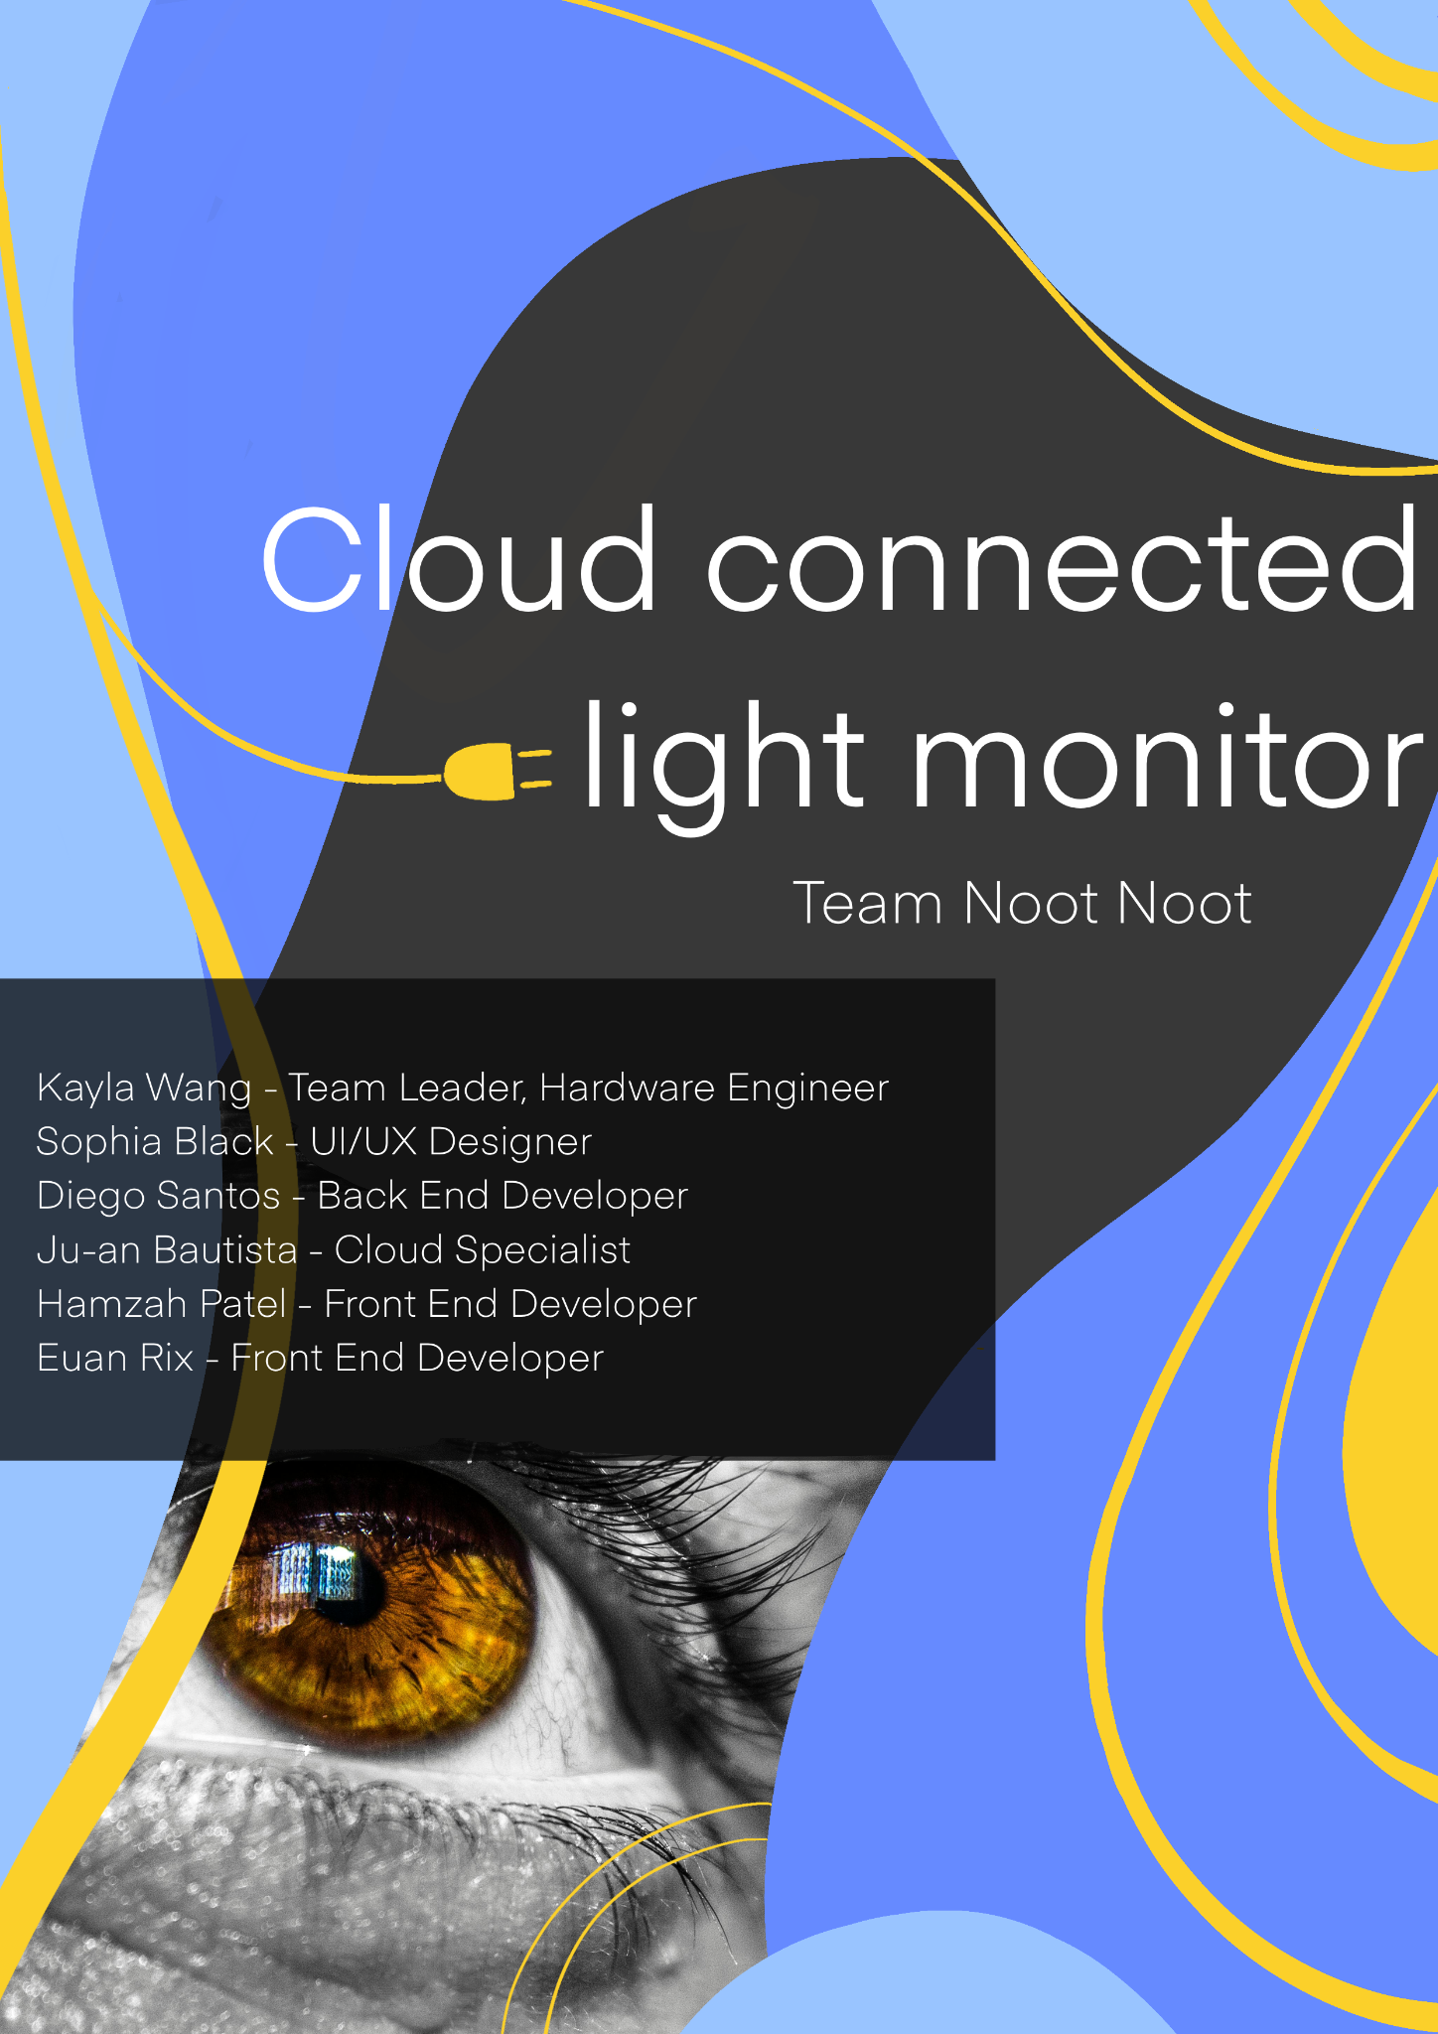



**Executive Summary**

"Any sufficiently advanced technology is equivalent to magic."[1]

Myopia, or nearsightedness, is a vision issue that is often observed in children and teenagers between the ages of 8 and 12. By 2050, it is projected that 50% of the world's population will be affected by Myopia[2]. An influence hypothesised to have added to this trend is an increase in time spent indoors. Combatting this influence is the challenge our group is aiming to undertake.

Our project aims to create a way for parents to monitor and increase the amount of time their child spends outdoors, a solution to tackle Myopia's manifestation in children and teens. We are also considering our client's request to retrieve better (and ethically sourced) data for researchers in the field of Optometry, such as themselves.

We aim to tackle our project on two fronts. First, we will utilise a UV sensor and a light sensor to send signals to a Raspberry Pi, which we will then use to monitor the amount of time a child spends outdoors. Then, an android application where we can display these results in a way that is easy for the everyday person to analyse. Another stretch goal we are considering is how our client can effectively convert our prototype into a wearable device fit for children.

As computer science students undertaking our final semester or final year, we believe we can excel in this challenge. Many of us have finished (or are currently undertaking) COMPSCI 235 (Software Development Methodologies) and COMPSCI 331(Large-Scale Software Development), allowing us the tools to work well as a group. COMPSCI 345 (Human-Computer Interaction) has given us the skills to design and build software that is appealing and easy to use for the average person, and PHYSICS 140 (Digital Fundamentals) has given us experience in interacting with hardware quite similar to the instruments we wish to use for this project. We have already dedicated ourselves to various roles in this project based on our respective expertise, and have drafted a schedule to make sure that milestones are completed by specific dates. Lastly, we communicate on a regular basis, allowing us to help each other if needed and keeping us accountable for completing the tasks we are given.

**Background and Rationale**

Myopia, also known as nearsightedness, is a common condition that usually starts in childhood. However, the speed at which myopia numbers are increasing is not common.

“The prevalence of myopia is increasing extensively worldwide. The number of people with myopia in 2020 is predicted to be 2.6 billion globally, which is expected to rise up to 4.9 billion by 2050, unless preventive actions and interventions are taken.”[3]

Why is the prevalence of myopia growing at such a rate? This global rise is not due to genetic factors alone.[4] Environmental factors are key here; less time spent outdoors has been shown to be a significant risk factor for myopia and its progression. There is also evidence that increased ‘near work’, such as writing or looking at a device from a short distance, can worsen this risk further.[5] In highly urbanised areas with long schooling hours, we see the number of students with myopia increase significantly, backing this claim. A study on high school students in Beijing found a staggering 80% of the students had myopia.[6] It is understood that long school hours, high amounts of near work, and the lack of outdoor activities are the leading causes of these concerningly high statistics. 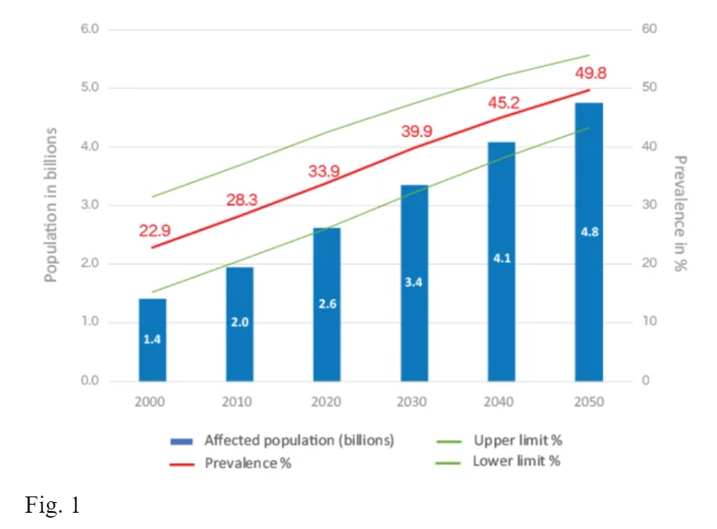

It is not only the number of individuals with myopia increasing, however, but also the severity of myopia itself that is worsening. It is said that high and pathological myopia is expected to be the “most common cause of irreversible vision impairment and blindness worldwide”[7]. From this, we can see the severity and scale of this issue demand better prevention technologies.

There are several effective ways to help prevent and reduce myopia, particularly in children, such as 1% atropine eye drops and multifocal contact lenses.[8] These measures, however, require the child to visit an optometrist and be at risk of, or already in the process of developing myopia.

Fortunately, there is evidence that the management of environmental factors such as sunlight is effective in lowering the risk of developing myopia and slowing its progression. We also know this can be provided for all children without the same monetary or medical barriers as pharmaceutical measures. Just two hours outdoors a day for children can help significantly reduce myopia risk. Studies have shown that the chances of kids becoming myopic is reduced by around one-third if time spent outdoors is increased from 0 to 5 hours per week to 14 or more hours per week.” [9] Another suggested that with an increase in time spent outdoors from 1 hour to 3 hours per day, the risk of myopia could be reduced by 50%.[10] Not only that, but spending more time outdoors also has other positive outcomes for children and adolescents, such as obesity prevention and promoting a healthier lifestyle.”[11]

Despite the many benefits of myopia management through sunlight, there are currently no full-scale solutions involving light-sensing devices and applications to help parents and children preserve their vision. While some applications can help parents track how long their kids spend outdoors, like ‘1000 hours outside,[12]’ and ‘myopia.app’[13], they do not involve a light sensing device, and times must be manually entered. UV sensing smart devices like ‘Sun Index’[14] do exist on the market, although they do not have a light level sensor to track time spent outdoors and are therefore not useful for myopia management.

Our solution aims to create an app to help parents keep track of their child’s time outside and automate this process through a purpose-built wearable light-sensing device. Not only this but we also plan to use this device to record accurate and ethical data for use in further studies into myopia by optometrist researchers at the University of Auckland.

**Specific Aims**

This project aims to construct a prototype device that can measure UV and lux exposure using an Arduino. The device will facilitate cloud synchronisation to a database, allowing access from a mobile Android app. The app is where the light monitoring can be visualised through graphs and statistics.

There are four specific goals our team has proposed:

Integrate light sensors that can accurately measure UV and lux exposure levels:

* Implement light sensors on the Arduino that can give accurate UV and lux exposure measurements. Accuracy will be measured through a series of controlled tests under the sun compared to an industry UV and lux measuring tool.
* The deadline for this goal will be in week 8

Design and build a compact and versatile device:

* In the client's best interest and the project's overall purpose, our final prototype will be easily transferable to a smaller wearable device using versatile and compact parts and technology. This will be measured by whether our hardware and software can be easily transferred onto other technology.
* The deadline for this goal will be in week 5

Cloud synchronisation and establishing the dataset:

* Once the device has collected data on light exposure, it will sync to our chosen cloud service provider and be recorded onto a dataset. We will ensure functionality by testing and performing several tests and simulations.
* The deadline for this goal will be in week 5

Android application with a comprehensive user interface:

* The Android app can show the light sensor's results using the database and cloud capabilities. There will be comprehensive graphs, statistics and information regarding the UV index, lux levels and changes in light intensity during the day. We will simulate a parent checking their child’s device at the end of the day to measure progress.
* The deadline for this goal will be in week 7

**Project Approach**

Tools

* Hardware: A Raspberry Pi 4 Model B, VEML6075 UVSensor and TSL2561 Light intensity LUX Sensor will be used to gather the user data. This hardware will be obtained through our client and may be subject to change subsequent to future client meetings.
* Project Management: Github Boards will be used to set tasks and track our progress to ensure that we implement correct Agile methodologies.
* Version Control: The use of Github will allow us to collaborate and review each other's code whilst enabling a safe workflow and mitigating risks of errors.
* UI/UX Design: Figma is a powerful design tool that will enable us to collaborate and test designs for our mobile app.

Technologies

Front-End: React Native will be employed for our front end to allow us to develop a responsive and scalable mobile application. React Native is a JavaScript framework which enables cross-platform development between IOS and Android devices.

Back-End: Java’s Spring-Boot framework will be utilised to manage our back-end. The embedded servers and auto-configuration of this framework will allow us to develop in a more optimised fashion.

Database: SQL will manage our database, as it’s flexible, secure, and easily scalable, which are all important when dealing with sensitive user data.

Cloud Infrastructure: Azure will be the backbone of all our cloud necessities.

Authentication: Azure Identity and Access Management (IDAM) will handle our user authentication requirements, and provide the users with security regarding their sensitive data.

Project Management Methodologies

To implement a robust Agile methodology, we will be using a SCRUM framework which utilises weekly sprint meetings and a Kanban board. A Kanban board enables us to create a structured and continuous workflow through weekly scrums, dividing project work into manageable and fair chunks. We decided on weekly sprint meetings as we have weekly client meetings, and we believe it is crucial that we discuss current work, future work, and any changes that need to be made due to the client meetings. A Gantt chart will also be used to assist in project planning, which will be created and used in Github. This framework requires a dedicated Scrum Master and Product Owner. A Scrum Master acts as a guide who can lead and promote correct Scrum methods. Thus, we believe this is important for project management, and will be assigning Kayla Wang as the Scrum Master. A product owner enables a clear flow of information between the client and the development team; however, we don’t see this as a necessity to designate, as we have weekly meetings with our client, during which the majority of the team will be in attendance.

**Team Organisation**

We have opted for designating each team member to one of two major components, Front-End and Back-End. We believe that separating the team this way will allow for better organisation of work and more engagement for each member. With each of our skill sets, we also believe that this will be the most efficient way to complete the project. While each member is separated into two separate groups, there will still be an overlap of work in some areas. By having a Scrum Master and frequent sprint meetings, we can resolve this by relying on the communication of the team to complete the tasks at hand.

The Front-End team will consist of Sophia Black (UI/UX Designer), Hamzah Patel (Front-End Developer) and Euan Rix (Front-End Developer). This team will primarily focus on the user's experience and interaction with the mobile app, as well as developing it. They will achieve this by utilising Figma for design and React Native for the execution. They will work alongside the Back-End team to ensure that the final product is a fully functioning application.

The Back-End team will consist of Kayla Wang (Hardware Engineer), Diego Santos (Back-End Developer) and Ju-an Bautista (Cloud Specialist). This team will primarily focus on the user's data through obtaining and storing it. They will achieve this by using the Raspberry Pi to obtain the data, SQL and Cloud infrastructure to store the data, and a Java Back-End to relay the data to the front end.

The goal of these two teams will be to work together synchronously and coherently to develop a final product exceeding the client's expectations.

Project Challenges

* Handling of sensitive data: Our biggest concern is the handling of data. We will be holding onto a variety of user information and collecting data. How this data is contained and transferred is paramount to the safety and security of the users.   
  To resolve this:
  + We will incorporate multiple cyber security principles, such as the principle of least data *(Only collect and store data for well-understood use)*
  + We will use robust data encryption and data transfer practices. This will guarantee that the appropriate safeguards are in place to ensure the confidentiality and integrity of user data as well as the authenticity of the user.
* Unfamiliar technology stack: While the task and objective are clearly outlined, our team faces a significant challenge due to the varying individual proficiency in each tool and technology used in this project.

To combat these challenges:

* + We will allocate time for team members to learn the new technologies via online resources, tutorials and workshops.
  + We will encourage team members to share what they have learned and their expertise with each other through collaborative sessions or internal documentation.
  + We will leverage existing skill sets within the team that can be applied to the new technology. This minimises the overall learning curve.
* Timing Constraints: Given the diverse schedules of each of the team members, coordinating a time for meetings where all of the team is available will pose a challenge. Additionally, the potential lack of communication due to the differing availability may cause delays in task completion.  
  To minimise this:
  + We will utilise asynchronous communication, such as project management platforms *(Github, Github boards)*, messaging apps *(Discord)*, and shared

documents to facilitate communication even when team members are unavailable at the same time.

* + We will use flexible scheduling by exploring options like staggered meetings or shorter, focused check-ins to accommodate diverse schedules.
* Stakeholder engagement: The involvement of the stakeholders is another challenge that we will face. It is essential for the progress of the project for the team to receive ample feedback from the client to ensure that the end result aligns with the client’s vision. Without sufficient input, the development stage may face major delay.  
  To minimise this:
  + We will handle this by establishing clear channels for feedback, such as regular meetings and emails for ongoing communication.
  + By keeping the stakeholders informed with regular progress reports, demos, or presentations. This fosters transparency and allows for early course correction if needed.

Deliverables

* A Raspberry Pi module to gather user data.
* A cloud infrastructure to store user data.
* An Android app to access user data.
* A report of how the device works and what data is collected.

**Project Plan**

Requirements and Information Gathering Phase (Weeks 1-3)

Objective:

Understand the scope and requirements of the project, make a decision regarding the technology stack that will be used as well as potential hardware to build prototype and gather relevant research information.

Task:

- Set up GitHub repository

- Have client meetings to answer any questions regarding technical requirements, required information and understanding of the desired Minimal Viable Product (MVP).

- Decide on the technology stack and potential hardware

- Define team member roles

- Research potential app designs

Design Phase (Week 4-5)

Objective:

Develop the UI and UX for the mobile app and draw out architecture for the backend to connect to the database and its connection to the hardware device.

Tasks:

- Create possible UI design concepts on Figma and have the team and clients decide on a preferred one

- Decide on functional and non-functional requirements (This will be used for quality assurance checks upon completion)

- Develop an architecture diagram of the backend

Development Phase (Week 6-10)

Objective:

Start the coding of the front-end and back-end, as well as the setup of the hardware and its required coding.

Tasks:

- Front-end dedicated members begin development of mobile app following the UI design.

- The back-end team will set up the connection to the database and functions for the mobile app

- The hardware team will connect and code for gathering the information required (either light intensity or UV ray)

Quality Assurance and Testing Phase (Week 11-12)

Objective:

Ensure that the prototype matches the client's standard and adheres to the teams agreed requirements

Tasks:

- Get feedback from the client

- Make any changes required depending on feedback

- Review functional and non-functional requirements and test if they have passed

- Documentation writing as part of quality assurance checks



****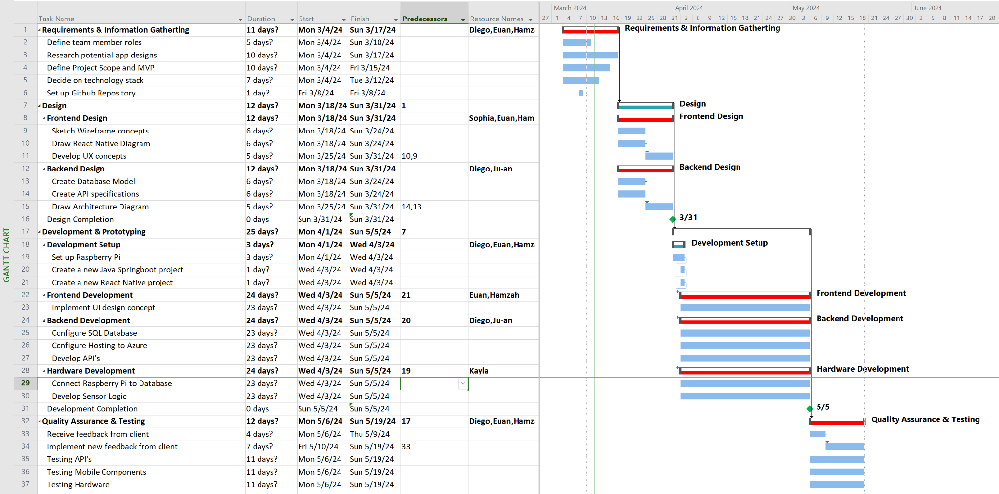

**References**

Executive summary:

* Foglia, Efraín, Ramon Mas Baucells, Óscar Marín Miró, Luis Paadín, Lucía Lijtmaer, and Ferran Esteve. “‘any Sufficiently Advanced Technology Is Indistinguishable from Magic.’” CCCB LAB, November 27, 2018. https://lab.cccb.org/en/arthur-c-clarke-any-sufficiently-advanced-technology-is-indistinguishable-from-magic/#:~:text=In%201962%2C%20in%20his%20book,technology%20is%20indistinguishable%20from%20magic%E2%80%9D

* Yoo, Sylvia H. “Myopia (Nearsightedness) in Children & Teens.” HealthyChildren.org, September 6, 2023. https://www.healthychildren.org/English/health-issues/conditions/eyes/Pages/Myopia-Nearsightedness.aspx
* Jost B. Jonas, Marcus Ang, Pauline Cho, Jeremy A. Guggenheim, Ming Guang He, Monica Jong, Nicola S. Logan, Maria Liu, Ian Morgan, Kyoko Ohno-Matsui, Olavi Pärssinen, Serge Resnikoff, Padmaja Sankaridurg, Seang-Mei Saw, Earl L. Smith, Donald T. H. Tan, Jeffrey J. Walline, Christine F. Wildsoet, Pei-Chang Wu, Xiaoying Zhu, James S. Wolffsohn; IMI, Prevention of Myopia and Its Progression. Invest. Ophthalmol. Vis. Sci. 2021;62(5):6. https://doi.org/10.1167/iovs.62.5.6
* Németh J, Tapasztó B, Aclimandos WA, Kestelyn P, Jonas JB, De Faber JHN, Januleviciene I, Grzybowski A, Nagy ZZ, Pärssinen O, Guggenheim JA, Allen PM, Baraas RC, Saunders KJ, Flitcroft DI, Gray LS, Polling JR, Haarman AE, Tideman JWL, Wolffsohn JS, Wahl S, Mulder JA, Smirnova IY, Formenti M, Radhakrishnan H, Resnikoff S. Update and guidance on management of myopia. European Society of Ophthalmology in cooperation with International Myopia Institute. Eur J Ophthalmol. 2021 May;31(3):853-883. doi: 10.1177/1120672121998960. Epub 2021.https://pubmed.ncbi.nlm.nih.gov/33673740/
* Lingham, G., Yazar, S., Lucas, R.M. et al. Time spent outdoors in childhood is associated with reduced risk of myopia as an adult. Sci Rep 11, 6337 (2021). https://doi.org/10.1038/s41598-021-85825-y
* Wu LJ, You QS, Duan JL, Luo YX, Liu LJ, et al. (2015) Prevalence and Associated Factors of Myopia in High-School Students in Beijing. PLOS ONE 10(3): e0120764. https://doi.org/10.1371/journal.pone.0120764



**Table of Authorship**

| **Section** | **Author(s)** |
| --- | --- |
| Title Page | Euan Rix & Sophia Black |
| Executive Summary | Juan Santos |
| Background | Sophia Black |
| Specific Aims | Kayla Wang |
| Project Approach | Hamzah Patel & Euan Rix |
| Project Plan | Ju-an Bautista |

ER, SB, MJ, KW, HP, DS



1. Efraín Foglia et al., “‘any Sufficiently Advanced Technology Is Indistinguishable from Magic.,’” CCCB LAB, November 27, 2018, https://lab.cccb.org/en/arthur-c-clarke-any-sufficiently-advanced-technology-is-indistinguishable-from-magic/#:~:text=In%201962%2C%20in%20his%20book,technology%20is%20indistinguishable%20from%20magic%E2%80%9D.
2. Sylvia H. Yoo, “Myopia (Nearsightedness) in Children & Teens,” HealthyChildren.org, September 6, 2023, https://www.healthychildren.org/English/health-issues/conditions/eyes/Pages/Myopia-Nearsightedness.aspx.
3. Németh J, et al, Update and guidance on management of myopia. *European Society of Ophthalmology in cooperation with International Myopia Institute*. p. 853, https://pubmed.ncbi.nlm.nih.gov/33673740/
4. Németh J, et al. op. cit., p. 853
5. Németh J, et al. op. cit., p. 861
6. Wu LJ, You QS, Duan JL, Luo YX, Liu LJ, et al. (2015) *Prevalence and Associated Factors of Myopia in High-School Students in Beijing.* p. 1, https://doi.org/10.1371/journal.pone.0120764
7. Németh J, et al. op. cit., p. 854
8. Jost B. Jonas et al., IMI Prevention of Myopia and Its Progression. p. 3-5, https://doi.org/10.1167/iovs.62.5.6.
9. Németh J, et al. op. cit., p. 862
10. Lingham, G., Yazar, S., Lucas, R.M. et al. Time spent outdoors in childhood is associated with reduced risk of myopia as an adult. Sci Rep 11, 6337 (2021). https://doi.org/10.1038/s41598-021-85825-y
11. Jost B. Jonas et al. op cit., p.1
12. https://www.1000hoursoutside.com/mobile-app
13. https://myopia.app/en/
14. https://sunindex.co/